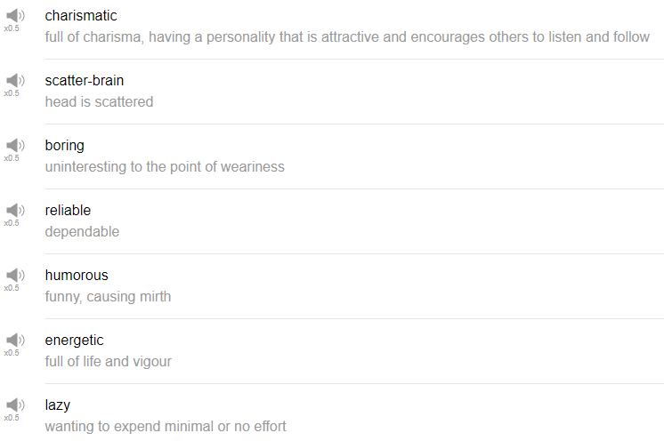

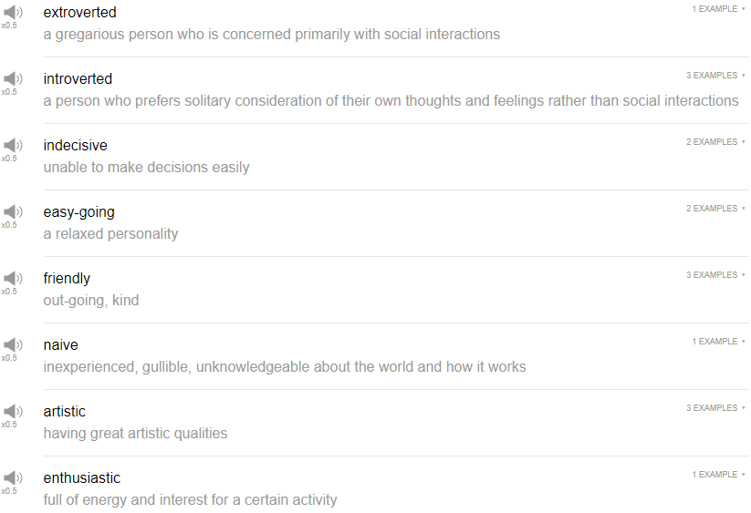

|  |
| --- |
| Let's begin the discussion of the personality adjective. |
| Hi, everybody, and welcome back to Top Words. My name is Alisha, and in today's episode we're going to be talking about what adjective describes your personality best. So let's go! |
| 1. Charismatic. |
| Someone who is charismatic is perhaps a good leader, people are drawn to them, people want to follow them, want to come to them. Charismatic doesn't necessarily mean that that person is a good person or a bad person, just that they are very good at drawing people to them. People tell me that I'm very charismatic. |
| 2. Boring. |
| Boring mean something that is not interesting. So hopefully nobody calls you boring, if you're a boring person, work on that. Let's talk about cardboard boxes. |
| 3. Reliable. |
| Reliable, someone who's reliable, someone that you can trust, or someone that always does what they say they're going to do. My best friend is very reliable. |
| 4. Humorous. |
| Humorous is just funny. There's a difference between funny and humorous and silly, in terms of people. Anyway, this is how i would break it down, silly is like appreciates, just very kind of childish stuff, or just enjoys laughing; funny is like a slightly more grown-up, funny, I feel like silly can be part of funny, silly can fit into funny, but funny is a little bit more grown-up, maybe your make like the actual word jokes, that are, you know, require a bit more knowledge or a bit smarter; and then humorous, humorous is like I feel like it's a bit more pretentious. I hope that my friend think that I'm a very humorous person. |
| 5. Energetic. |
| The next word is energetic. Energetic means you have a lot of energy. I personally don't use it, if someone says what's your best friend like? I wouldn't immediately think he's energetic, like, I feel like that's a given somehow, and when I say that's a given, it means it's it's an already understood idea. I would use energetic for something you would not expect to be energetic, my grandmother is very energetic, she hikes mountains even though she's 80 something. |
| 6. Lazy. |
| Yeah, you don't want to be called lazy generally, it means that you, maybe you're not hard-working, you don't take care of yourself, or you don't take care of your responsibilities. Generally lazy is not seen as a good thing, unless you use an expression like, today is a lazy Sunday. One of my co-workers is really lazy, he never has his stuff done on time. |
| 7. Extroverted. |
| Extroverted, it begins with that prefix EX-tro, like ex, meaning outside, so like extra, more information. So an extroverted person is a very outgoing person, they like talking, they like talking to people, they want to go out, and do all the things and be social and go yeah! I like being extroverted on this program. |
| 8. Introverted. |
| The opposite of extroverted is introverted. Introverted, inside something interior ,they want to not go talk to people all the time, or maybe they just have a different way of expressing their social skills. In reality, I'm a rather introverted person. |
| 9. Indecisive. |
| The next word is indecisive. Indecisive. Indecisive people drive me crazy. This word means someone who is bad at making decisions. I have a friend who is very indecisive, she can't ever make up her mind, I have to do it for her. |
| 10. Easygoing. |
| Easygoing is a good thing to be, generally, in my opinion. Easygoing means you're relax, you'll just do whatever, you're happy to just hang out, if someone makes a suggestion, you're cool with that. Alright, fine, that's great for me, I'll do whatever. My best friend is very easygoing, he's cool to do anything. |
| 11. Naive. |
| The next word is naive. So someone that doesn't have a lot of experience in a topic, or even life experience, could be considered naive. You don't want to be called naive, the suggestion with naive is that it's easy to take advantage of you, maybe you could be easily molded, or your experience can easily be changed by someone else. So generally naive is not a good thing, you don't want to be naive. My friend was very naive and got in trouble with a bad business deal. |
| 12. Artistic. |
| The next word is artistic. Yeah, artistic is a good word, similar to creative, perhaps. Artistic is someone who enjoys art, or enjoys creating things, so this doesn't, it's not limited to, you know, just art like paintings, you know, doing good paintings or sculptures or something like that. Any kind of creative endeavor, any kind of creative work, I feel you could use the word artistic for. My aunt is very artistic, she can draw very well. |
| 13. Enthusiastic. |
| Enthusiastic, this is similar to energetic, but it just means you're excited about things, you're enthusiastic about something usually. Sports fans are very enthusiastic about their favorite team. |
| 14. Friendly. |
| Friendly. I hope that you are friendly person, is someone maybe that it feels easy for you to talk to, someone that's chill, someone that's probably outgoing, maybe a bit extroverted is a friendly person. I went to an event on Saturday and everybody there was very friendly, it was a fun time. |
| How would I describe my personality? God, it depends on the day, man. The one that I use lately is scatterbrained, but that has a very negative connotation about it. Scatterbrained, if you break down the word scatter and brain, scatter means to spread something randomly, brain meaning inside your brain. I have so many different things going on that, like, I'm thinking about like this job, and that job, this project, that project, and I have to do this, and oh my god, my laundry is not done yet, and what am I gonna make for dinner tomorrow? My god! I have to go running later tonight, What I'm going to do? How many cups of coffee have I had? This is what's going on in my head. |
| Those are 15 words that you can use to talk about your personality, or to talk about someone else's personality. So you can try and use one of these words to describe your personality, Leave us a comment below and you can test it out. If there's a different word that you are interested in using to describe your personality or another person's personality, let us know about it. Thanks very much for watching this episode of Top Words and we will see you again soon. Bye! |